# MediTrack: Revolutionizing Patient Health History Management

***Sumedh Udupa U, Syed Muzammil Hussaini, Varun Gowda R***

***Under the Guidance of Dr.Vishalakshi Prabhu, Dr.Sandhya S – Department of Computer Science Engineering***

## Introduction

**In the fast-paced and ever-evolving world of healthcare, the efficient management of patient health data is critical to delivering high-quality, personalized care. Traditional methods of health history management, which often involve paper-based records or fragmented electronic systems, present numerous challenges, such as data inaccuracies, limited accessibility, and privacy concerns. These inefficiencies can compromise patient safety, lead to delays in care, and place a significant administrative burden on healthcare professionals.**

**MediTrack emerges as a comprehensive digital health history management solution aimed at revolutionizing the way patient data is stored, accessed, and utilized. By centralizing patient health records, MediTrack offers an integrated platform that enables seamless communication among patients, medical practitioners, and caretakers, ultimately improving the accuracy and continuity of care. The project places a strong emphasis on user-centered design, incorporating feedback and insights from diverse stakeholders to ensure the system meets real-world needs.providers manage patient information.**

## 1. Key Features of MediTrack

**MediTrack packs a multitude of features that streamline patient health history management. Some of the crucial components include:**

**Centralized Data Management: Consolidate patient health records into a single, secure platform accessible by authorized users.**

**Enhanced Security and Privacy: Employ robust data protection measures, including encryption and role-based access, to safeguard sensitive patient information.**

**User-Friendly Interface: Design an intuitive and easy-to-navigate system that simplifies data access for patients, doctors, and caregivers.**

**Integration with Existing Systems: Ensure compatibility with existing hospital systems and health apps, streamlining data flow and minimizing manual input.**

**Personalized Health Insights: Offer tailored health management features, including predictive analytics, appointment reminders, and customizable dashboards.**

**This project report delves into the Empathy Phase, where the needs and challenges of key stakeholders are explored, and the Ideate Phase, where innovative solutions are conceptualized using diverse ideation techniques. By focusing on empathy-driven design and creative problem-solving, MediTrack aims to transform the healthcare experience for all involved parties, from individual patients to the broader medical community.**

**EMPATHY PHASE**

**The Empathy Phase is a critical stage in developing MediTrack, as it involves deeply understanding the challenges, motivations, and perspectives of diverse stakeholders involved in patient health data management. By focusing on empathy-driven insights, we ensure that the resulting solution addresses real user needs.**

**1. Problem Statement**

**1.Disconnected Health Data**

**•Description: Patients’ health data is often distributed across multiple hospitals, clinics, and healthcare systems. This fragmentation makes it difficult for doctors to access a comprehensive medical history, resulting in incomplete treatment information.**

**•Impact: Incomplete data can lead to misdiagnoses, repeat tests, treatment delays, and compromised patient care. It also creates inefficiencies for healthcare professionals who need to manually piece together a patient’s medical background.**

**2.Inefficient Tracking**

**•Description: The use of paper records and non-digital methods for tracking patient history leads to a cumbersome and time-consuming process, with potential errors in data handling and storage.**

**•Impact: Manual systems increase administrative burden on healthcare staff, reduce the amount of time they spend with patients, and lead to inaccuracies that may adversely impact patient health outcomes.**

**3.Lack of Personalization**

**•Description: Existing health tracking solutions often fail to consider individual patient needs, medical conditions, and preferences, making it difficult for users to effectively engage with their health records.**

**•Impact: This can lead to low adoption rates, patient dissatisfaction, and lack of control over their own health data.**

**2. Stakeholders’ Points of View (POV)**

**A. Medical Practitioners (Doctors, Nurses, etc.)**

**•Challenges:**

**•Data Gaps: Patients often visit multiple healthcare providers, resulting in scattered records and data inconsistency.**

**•Time Constraints: Collecting and synthesizing patient information is time-consuming, affecting the quality and timeliness of care.**

**•Needs:**

**•Access to comprehensive, up-to-date patient records to make informed decisions quickly.**

**•Seamless integration with existing electronic health record (EHR) systems.**

**B. Patients**

**•Challenges:**

**•Uncertainty: Patients often feel unsure about the completeness and accuracy of their medical history.**

**•Privacy Concerns: Worries about the security of their sensitive data when shared across multiple providers.**

**•Convenience: Difficulty in accessing their records when needed, especially when changing providers or relocating.**

**•Needs:**

**•Control over their health data with user-friendly digital tools.**

**•Assurance of data security and privacy.**

**C. Caretakers (Family Members, Supporters)**

**•Challenges:**

**•Incomplete Information: Limited access to a patient’s comprehensive health history during emergencies.**

**•Medication Management: Challenges in tracking medication schedules for patients with chronic illnesses.**

**•Needs:**

**•Quick access to relevant patient information in emergencies.**

**•Accurate, up-to-date data to ensure appropriate care and support.**

**D. Government and Regulatory Bodies**

**•Challenges:**

**•Regulatory Compliance: Ensuring that all digital health solutions comply with privacy and data security regulations (e.g., HIPAA).**

**•Needs:**

**•Digital systems that adhere to ethical data practices and prioritize patient rights.**

**3. Empathy Map**

**•Medical Practitioners (Doctors/Nurses)**

**•Sees: Fragmented patient health data, incomplete records, and inconsistent medical histories.**

**•Thinks: “How can we efficiently gather and synthesize all relevant patient data to provide the best care possible?”**

**•Feels: Frustrated due to the time-consuming nature of manual data handling, leading to potential errors and inefficiencies.**

**•Does: Seeks out digital tools and innovative solutions to streamline data tracking and enhance patient care.**

**•Patients**

**•Sees: Disparate records scattered across different locations and providers.**

**•Thinks: “Is my medical data secure and complete when I change providers or travel?”**

**•Feels: Anxiety and uncertainty about data privacy and completeness of records.**

**•Does: Prefers convenient access to health data and digital tools that make health management simpler.**

**•Caretakers**

**•Sees: Limited or incomplete information available during emergencies.**

**•Thinks: “How can I ensure the health data of my loved one is always up-to-date and accessible?”**

**•Feels: Stress and worry about missing or outdated health data potentially compromising care.**

**•Does: Engages with tools to maintain accurate health records and quick access during emergencies.**

**4. User Journey Map**

**The User Journey Map identifies key touchpoints and interactions with MediTrack, outlining the experience of users from initial data entry to routine use and feedback.**

**1. Awareness**

* **Touchpoint: Initial introduction to MediTrack.**
* **Actions:**
  + **Patients and healthcare providers are introduced to MediTrack through marketing, referrals, or recommendations within healthcare facilities.**
  + **Information sessions or demonstrations highlight the benefits of digital health record management.**
* **Goal: To create interest and inform potential users about the benefits of centralized health record management with MediTrack.**

**2. Consideration**

* **Touchpoint: Evaluation of MediTrack's features and benefits.**
* **Actions:**
  + **Patients and providers explore MediTrack’s functionalities (e.g., data security, accessibility, ease of use).**
  + **They may seek feedback from existing users or participate in demo sessions.**
* **Goal: To ensure users understand how MediTrack can meet their specific health record management needs.**

**3. Decision**

* **Touchpoint: Choosing to use MediTrack.**
* **Actions:**
  + **Users decide to register and adopt MediTrack for health data management.**
  + **They may consult with administrative or technical staff to facilitate the transition.**
* **Goal: To encourage a confident commitment to MediTrack for streamlined health record handling.**

**4. Onboarding**

* **Touchpoint: Initial data entry and account setup.**
* **Actions:**
  + **Patients manually input or import data, uploading necessary medical records.**
  + **System prompts for a step-by-step guided setup, making it easier to input comprehensive information.**
  + **Initial data verification ensures accuracy for future use.**
* **Goal: To provide a smooth onboarding process, ensuring essential patient data is entered accurately and efficiently.**

**5. Usage**

* **Touchpoint: Day-to-day interaction with MediTrack.**
* **Actions:**
  + **Healthcare providers access patient data for diagnostic, treatment, and follow-up purposes.**
  + **Patients view their own data, track progress, and receive alerts or reminders about appointments or medication.**
  + **Data updates are logged in real-time, ensuring that all stakeholders have access to the most recent information.**
* **Goal: To enable efficient, ongoing use of MediTrack for real-time health record access, supporting better healthcare outcomes.**

**6. Feedback and Continuous Improvement**

* **Touchpoint: Regular input from patients and providers.**
* **Actions:**
  + **Patients and staff report any data inconsistencies or usability challenges, submitting feedback directly through MediTrack.**
  + **MediTrack responds to feedback by rolling out updates, addressing issues, and enhancing user experience.**
* **Goal: To facilitate iterative improvements, maintaining high user satisfaction and data accuracy.**

**5.Insights Derived:**

**•Focusing on empathy-driven development ensures that the system prioritizes the needs of patients and healthcare providers.**

**•Key principles include security, personalization, and a user-friendly design that bridges data gaps and enhances healthcare deliver**

**IDEATE PHASE**

**The Ideate Phase is a crucial step in developing MediTrack as it focuses on generating a wide range of innovative solutions using different ideation techniques. This stage leverages creativity and diverse perspectives to ensure the solutions are user-centric, practical, and address the key challenges faced by stakeholders.**

**1. Brainstorming**

**Description: Brainstorming involves a group of participants generating as many ideas as possible to solve a given problem, building on one another's thoughts to create a wide pool of solutions.**

**•Ideas Generated:**

**1.Cross-Hospital Data Sharing Platform: Enables seamless exchange of patient data across different hospitals and clinics, reducing fragmented data.**

**•Reason: Facilitates consistent and accurate care by providing doctors with a complete patient history.**

**2.Real-Time Data Synchronization: Updates patient records in real-time across all connected systems.**

**•Reason: Ensures up-to-date information is available for accurate diagnosis and treatment.**

**3.User-Friendly Patient Dashboard: Customizable interface displaying key health data, upcoming appointments, and alerts.**

**•Reason: Empowers patients to take charge of their health management.**

**4.Integration with Health Apps: Connects MediTrack with popular health-tracking applications for a holistic view of patient health.**

**•Reason: Enhances monitoring capabilities and provides comprehensive insights.**

**5.Encrypted Data Sharing Mechanism: Ensures secure sharing of sensitive health data between providers.**

**•Reason: Maintains data privacy and compliance with regulations.**

**6.Role-Based Access Control: Restricts data access based on user roles (doctors, patients, family members).**

**•Reason: Enhances security while allowing necessary access.**

**7.Automatic Data Updates from Hospital Systems: Minimizes manual data entry by automating data flow from hospitals.**

**•Reason: Reduces patient and administrative burden, ensuring up-to-date records.**

**8.Quick Emergency Access System: Provides healthcare providers with instant access to critical patient data during emergencies.**

**•Reason: Saves time and ensures prompt, accurate care.**

**9.Predictive Health Analytics Dashboard: Offers health risk predictions based on patient data trends.**

**•Reason: Enables proactive healthcare management.**

**10.Appointment Booking and Reminder System: Allows patients to book appointments and receive reminders.**

**•Reason: Improves patient adherence to care schedules and reduces missed visits.**

**2. Worst Idea Technique**

**Description: This technique involves deliberately generating the "worst" possible ideas to highlight areas for improvement, then flipping these ideas into positive solutions.**

**•Worst Ideas and Transformations:**

**1. Charge patients a fee to access their own medical records.**

**•Transformation: Provide free access to essential health records to empower patients.**

**2. Have no security or encryption for patient data.**

**•Transformation: Implement strong encryption and role-based access control for data privacy.**

**3. Design a complex interface that requires medical knowledge.**

**•Transformation: Create an intuitive and user-friendly interface accessible to all users.**

**4. Fragment data for each hospital visit, creating separate records.**

**•Transformation: Consolidate all patient data under a single, centralized record.**

**5. Require manual data entry for every patient interaction.**

**•Transformation: Introduce automation and integration with existing systems to streamline data entry.**

**3. Storyboarding**

**Storyboard Scenario 1: Emergency Access to Medical History**

* **Scene 1: Ramesh, a patient with a chronic condition, experiences severe symptoms and rushes to the ER. The emergency doctor asks for his past medical history to make informed treatment decisions.**
* **Scene 2: Ramesh struggles to remember his complex medical history, and the hospital’s staff can’t access his records from another hospital, causing delays.**
* **Scene 3: With MediTrack, the ER doctor quickly pulls up Ramesh’s full medical history on a digital dashboard, including recent tests, medications, and allergies.**
* **Insight: Highlights how MediTrack supports emergency care by providing rapid access to essential patient information, improving response times and treatment quality.**

**Storyboard Scenario 2: Follow-Up Appointment Efficiency**

* **Scene 1: An elderly patient, Mrs. Devi, has a follow-up with her doctor after a recent surgery. The doctor needs to review her recovery progress, medications, and recent lab results.**
* **Scene 2: Mrs. Devi brings a stack of paper records, but some files are missing, and finding the right information is time-consuming.**
* **Scene 3: With MediTrack, the doctor accesses Mrs. Devi’s updated health records instantly, including notes from the surgical team and lab results, allowing more time for meaningful discussion on her recovery plan.**
* **Insight: Demonstrates the value of MediTrack in enhancing follow-up care by making patient records easily accessible, saving time, and ensuring a comprehensive review.**

**Storyboard Scenario 3: Medication Management for Chronic Illness**

* **Scene 1: Ajay, a patient with diabetes, frequently visits his clinic for regular check-ups. His doctor needs to track his blood sugar levels, medication adherence, and dietary habits.**
* **Scene 2: Ajay struggles with inconsistent record-keeping, forgetting doses or tests, leading to incomplete data during appointments.**
* **Scene 3: With MediTrack, Ajay’s doctor views a consolidated record of his daily health metrics, prescriptions, and compliance reports, helping to make timely adjustments to his treatment plan.**
* **Insight: Highlights how MediTrack supports ongoing care for chronic conditions by providing consolidated and up-to-date information, enabling better monitoring and personalized treatment adjustments.**

**4. Mind Mapping**

**Central Concept: Digital Health Record Management**

**1. Security**

* **Data Encryption**
  + **End-to-end encryption for patient data in transit and at rest.**
  + **Advanced encryption standards (AES-256) to protect sensitive health information.**
  + **Regular encryption key rotation to prevent data breaches.**
* **Role-Based Access Control (RBAC)**
  + **Customized access levels for patients, doctors, and administrative staff.**
  + **Permissions based on roles, limiting access to specific data sets.**
  + **Access logs and audit trails to track any unauthorized attempts or misuse.**
* **Multi-Factor Authentication (MFA)**
  + **Multi-layer authentication (e.g., passwords, biometrics, OTP) for added security.**
  + **Alerts for suspicious login attempts and session tracking.**
* **Compliance and Legal Frameworks**
  + **Adherence to healthcare privacy standards (e.g., HIPAA, GDPR).**
  + **Regular audits and security assessments to maintain compliance.**
  + **Patient consent management for data sharing, ensuring ethical handling of data.**

**2. Access**

* **Patient Dashboard**
  + **User-friendly interface displaying comprehensive health summaries, medical history, and recent visits.**
  + **Tools for patients to upload personal health data or connect wearable health devices.**
  + **Notifications and reminders for medications, appointments, or follow-ups.**
* **Cross-Hospital Data Sharing**
  + **Seamless data sharing between hospitals, clinics, and labs for continuity of care.**
  + **Compatibility with various EHR systems to enable interoperability.**
  + **Access control options for external health providers with patient consent.**
* **Mobile Access**
  + **Secure mobile app for patients to view records, book appointments, and receive health updates.**
  + **Integration with wearables for real-time health tracking (e.g., heart rate, blood pressure).**
* **Telemedicine Integration**
  + **Access to patient data for remote consultations and telemedicine sessions.**
  + **Direct upload of telemedicine notes and prescriptions to the patient record.**
* **Emergency Access Protocols**
  + **Authorized emergency access to critical patient data (e.g., allergies, medications) in emergencies.**
  + **Limited-time access for emergency personnel, ensuring patient safety.**

**3. Automation**

* **Real-Time Updates**
  + **Instant updates to patient records after lab tests, imaging, or new prescriptions.**
  + **Push notifications for patients and healthcare providers for any significant changes.**
* **Automated Hospital Data Integration**
  + **Direct syncing with hospital data systems for lab results, imaging reports, and discharge summaries.**
  + **AI-based categorization of new data to organize and classify patient records automatically.**
* **Medication Reminders**
  + **Automated reminders for patients to take medication, refill prescriptions, or attend appointments.**
  + **Customizable notification settings for patients to adjust according to their schedule.**
* **Data Validation and Error Detection**
  + **AI-driven algorithms to detect inconsistencies or errors in data entry.**
  + **Alerts to healthcare staff if critical data is missing or incorrect.**
* **Automated Billing and Insurance Claims**
  + **Integration with billing systems for seamless processing of medical bills and insurance claims.**
  + **Pre-filled insurance forms based on patient records to expedite claims.**

**5. Brainwriting**

**Description: Participants independently write down ideas before discussing them as a group, promoting a broad range of concepts without immediate judgment.**

**•Generated Ideas:**

**1. Health Data as a Digital Passport for Cross-Border Healthcare**

* **Concept: Patients carry a secure, universally compatible health record that acts as a “passport” for global healthcare.**
* **Benefits: Ensures seamless, informed care across borders; reduces redundant testing.**
* **Implementation: International standards integration, encryption, and consent-based access.**

**2. Mobile App Integration for On-the-Go Health Management**

* **Concept: A mobile app for viewing records, booking appointments, and tracking health data anytime.**
* **Benefits: Empowers patient engagement, supports telemedicine, and enables real-time tracking.**
* **Implementation: Secure app with multi-factor authentication, wearable device integration, and real-time data sync.**

**3. Personalized Reminders for Medication and Appointments**

* **Concept: Automated reminders for medication and appointments tailored to patient schedules.**
* **Benefits: Improves adherence, reduces missed doses, and allows caregiver notifications.**
* **Implementation: SMS/email alerts, customizable timing, and adaptive notifications based on usage.**

**4. Anonymous Data Sharing for Healthcare Research**

* **Concept: Secure, anonymized data sharing to support medical research without compromising privacy.**
* **Benefits: Advances research while protecting patient identity.**
* **Implementation: Anonymization techniques and compliance with data privacy laws.**

**5. Language Customization for Diverse Patient Needs**

* **Concept: Support for multiple languages to enhance accessibility for diverse users.**
* **Benefits: Improves usability for non-native speakers, enhancing care quality.**
* **Implementation: Language options for the app and dashboards, culturally sensitive designs.**

**6. Questioning Assumptions**

**Description: This technique challenges preconceived assumptions to uncover new possibilities.**

**1. Assumption: Health data is always available online.**

* **Idea: Enable offline access for emergencies.**

**2. Assumption: Patients always update their data.**

* **Idea: Automate data syncing with hospital systems.**

**3. Assumption: Only doctors need access to patient records.**

* **Idea: Allow approved family members controlled access.**

**4. Assumption: Only adults need access to health records.**

* **Idea: Provide simplified access for adolescents, with parental consent.**

**5. Assumption: Patients have smartphones to access their health records.**

* **Idea: Offer SMS-based access for those without smartphones.**

**6. Assumption: Health records are only relevant during medical visits.**

* **Idea: Allow patients to view health trends between visits.**

**7. Assumption: Health records only cover physical health.**

* **Idea: Integrate mental health records for comprehensive care.**

**8. Assumption: Health data is static after hospital visits.**

* **Idea: Enable patients to add personal health data (e.g., diet, exercise).**

**7. Analogies**

**Description: Drawing comparisons to familiar concepts helps to spark innovative ideas.**

**•Analogies Used:**

**1. Health Data as a “Digital Passport”**

* **Analogy: Like a passport provides secure, recognized access across borders, MediTrack’s digital health record enables seamless healthcare across facilities and systems, ensuring continuity of care globally.**

**2. Records System as a “Health Vault”**

* **Analogy: Similar to a bank vault securing valuable assets, MediTrack acts as a secure “vault” for health data, prioritizing privacy, encrypted access, and strict permissions.**

**3. Health History as a “Health Timeline”**

* **Analogy: Like a personal timeline captures life events, a “Health Timeline” in MediTrack organizes medical records chronologically, making it easy for patients and doctors to track health events and treatments over time.**

**These analogies foster a clear, user-friendly understanding of MediTrack’s features, focusing on security, accessibility, and intuitive data organization. This Ideate Phase supports a practical, user-centered solution for enhanced digital health management.**

**PROTOTYPE PHASE**

**Medi-Track** provides a seamless and professional user experience. It includes options for **Login** and **Register** using a **unique ID and email** to ensure secure access.

**Role-Based Access**:

**Patients**: Access to personal medical history, allergies, and past treatments.

**Doctors**: View and update patient records, add diagnoses, and manage medical insights.

**Administrators**: Oversee system operations, manage user roles, and ensure data security.

**Landing Page**

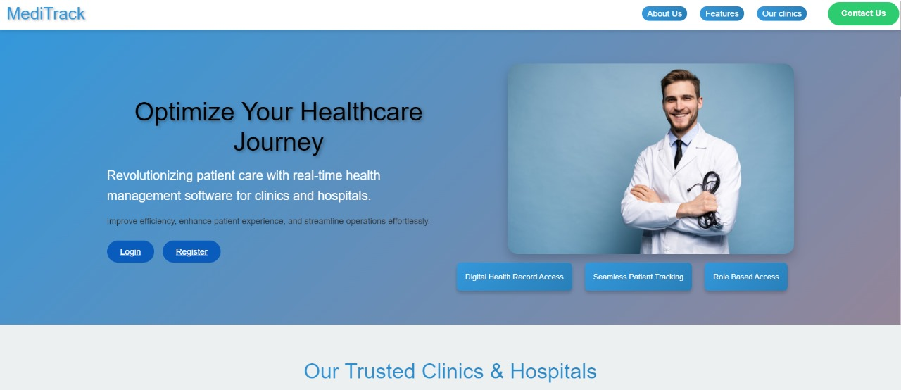

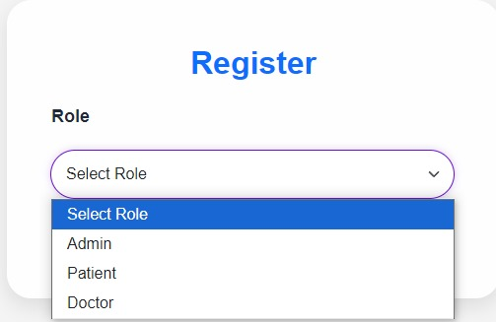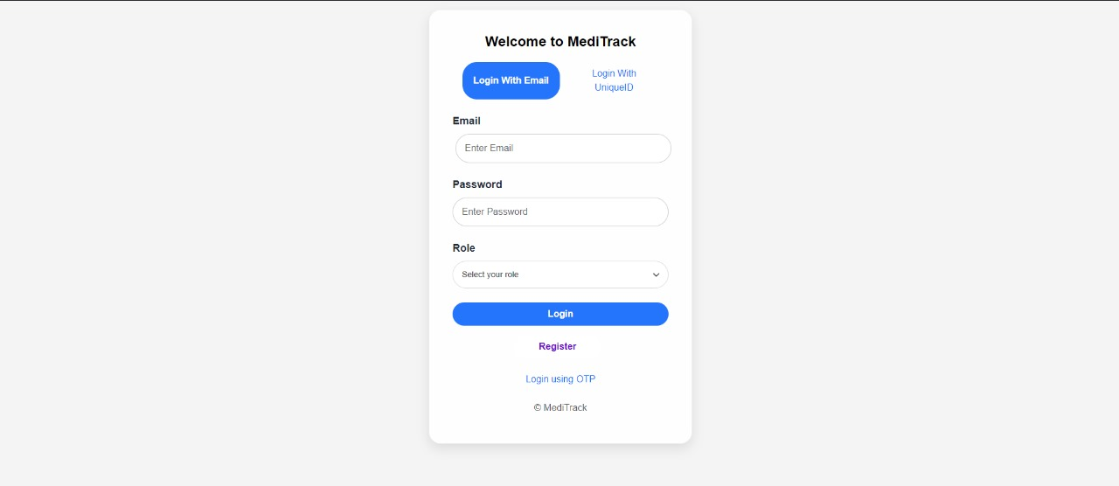

**Login and Register**

The landing page of **Medi-Track** provides a seamless and user-friendly experience with a clean, professional design. It includes options for users to **Login** or **Register**, ensuring easy access to the platform. The page highlights key sections such as **About Us**, which introduces the platform's purpose, and **Features**, which outline the core functionalities like medical history tracking, allergy management, and predictive insights.

Additionally, it showcases **Trusted Doctors and Clinics** to build credibility and trust with users. A **Contact Us** section is available for inquiries and support, making communication straightforward. The landing page combines clarity and functionality, ensuring visitors quickly understand and engage with the platform.

**ADMIN DASHBOARD**

The **Medi-Track Admin Dashboard** provides an intuitive interface for administrators to manage the system effectively. It includes the following key functionalities:

* **Patients**: View, update, and manage patient records.
* **Doctors/Practitioners**: Manage doctor profiles, assign roles, and oversee practitioner-related data.
* **User Management**: Control access levels, add or remove users, and ensure system security.
* **Appointments**: Monitor and manage appointment schedules for doctors and patients.

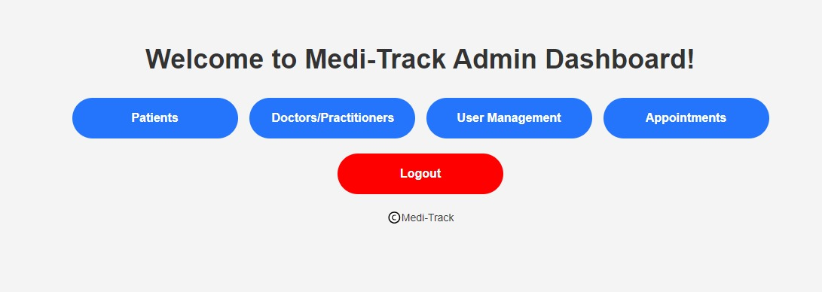

**PATIENT DASHBOARD**

The **Patient Dashboard** allows patients to manage their health information in a user-friendly interface. Key features include:

1. **My Medical Records:** Patients can view and track their medical history, including diagnoses, treatments, and prescriptions.
2. **Appointments:** The dashboard displays upcoming appointments, including details about the date and time of visits.
3. **My Entries:** This feature allows patients to make personal health entries and track symptoms, lifestyle, and health parameters.
4. **Find Doctors:** Patients can search for doctors based on specialties, location, and availability.
5. **Logout:** Patients can log out securely once they are done accessing their information.

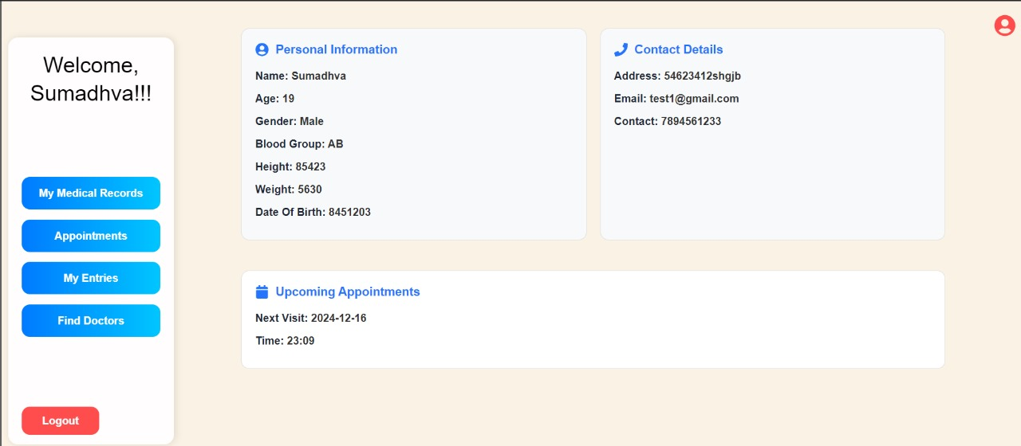

**DOCTOR DASHBOARD**

he **Doctor Dashboard** is designed to provide medical professionals with easy access to patient information, medical records, appointments, and more. The dashboard includes the following key features:

1. **Patients:** Access to the list of patients under the doctor's care, allowing for quick view and management of their details.
2. **Medical Records:** Doctors can view and update medical records of their patients, including adding new diagnoses, treatment plans, and medical insights.
3. **Appointments:** View upcoming appointments, manage scheduling, and track patient visits.
4. **Logout:** Doctors can securely log out after completing their tasks.

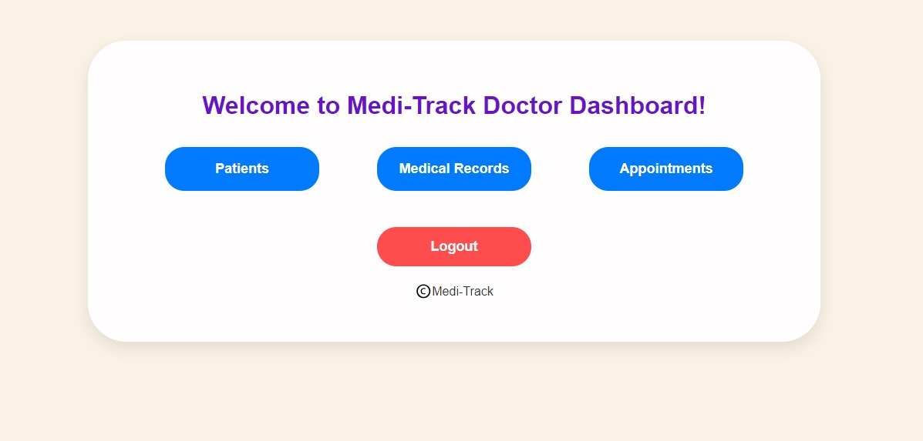

**DATABASE STRUCTURE**

For **Medi-Track**, the system uses two distinct databases to handle different types of data effectively:

**MongoDB (for text-based data):**

1. MongoDB is used to store textual data, including:
2. Patient medical records (textual history, diagnoses, etc.)
3. Appointment scheduling data
4. User profiles for patients, doctors, and administrators
5. MongoDB offers flexible and scalable document storage, making it ideal for managing and querying large amounts of unstructured text data.

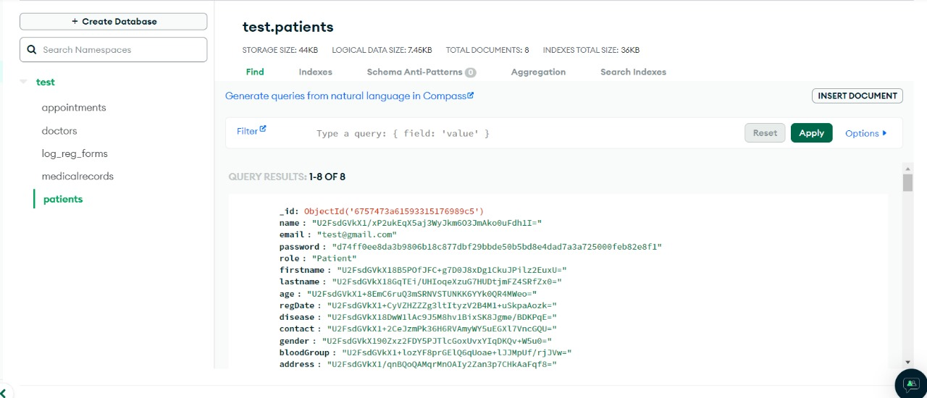

**Firebase (for documents and media):**

1. Firebase is used to store documents and media files such as:
2. Medical images (X-rays, scans, prescriptions)
3. Patient documents (insurance details, consent forms)
4. Firebase provides a real-time database and cloud storage, ensuring that media files are securely uploaded, stored, and accessible from various devices in a seamless manner.

